
Year 9

Semester One Exam-Section 1

No resources allowed

Name: ______________________ Class: ______ Time: 15 minutes Total Mark(1):____/14
Total Mark(1+2):____/52

Questions 1 to 6 are multiple choice and you need to circle your answer.
[6 marks]
- Which of the following ratios is equivalent to 6 : 10?
A 4 : 6 B 9 : 15 C 10 : 20 D 30 : 35

- Mary’s age and her daughter’s age are in the ratio 11 : 3. If Mary is aged 44, how old is her daughter?
A 6 B 9 C 12 D 22

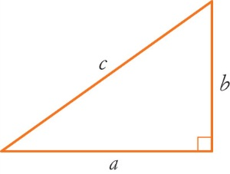
- Which of the following sides is the hypotenuse of this triangle?
A a B b

C c D a or b

- Which of the following mathematical statements is false?

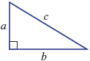
A B C

D E

- For the right-angled triangle shown, the value of x is given by:
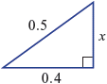

A B C

D E

- Which graph is in direct proportion?
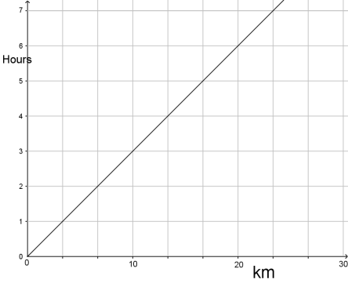
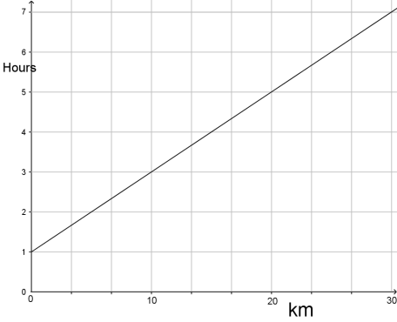
A B

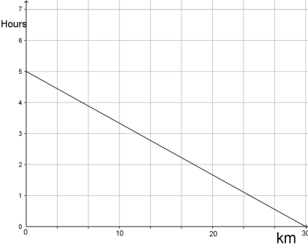
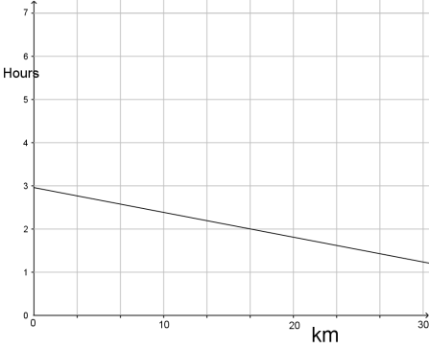
C D

- Simplify the following ratios
[4 marks]
  - $10 :5$ =2:1

  - $\frac{1}{2}:\frac{2}{3}=3:4$

  - $1\frac{2}{5}:\frac{1}{4}=28:5$

  - $0.3:1.2$ = 1:4

- Which of the following pairs of ratios are in proportion?
[4 marks]

First | Second | In Proportion  Yes/No
1:2 | 12:24 | Yes
10:16 | 25:40 | Yes
12:15 | 30:24 | No
1:0.4 | 5:2 | Yes


Year 9

Semester One Exam-Section 2

Resources allowed-Scientific calculator/One page of notes

Name: ______________________ Class: ______ Time: 35 minutes Total Mark(2):____/38

Questions 9 to 10 are multiple choice. Circle the correct answers.
[2 marks]
- Ben rides his bike for minutes and travels 750 m. What is his average speed?

A 150m/min B 250m/min C 300m/min D 350 m/min

- In its simplest form, the ratio 60c : $5 is:

A 60 : 5 B 3 : 20 C 1 : 8 D 3 : 25 E 6 : 50

- A car travels 100km on 7.5L of petrol. How far would the car travel with 48L of petrol? Show your working.
[2 marks]

$$\frac{x}{100}=\frac{48}{7.5}⇒x=640km$$

- It takes 40 minutes to travel from Baldivis to Perth at an average speed of 65km/hr. How long would the journey take if the average speed increased to 80km/h? Show your working
[3 marks]

$$\frac{x}{40}=\frac{65}{80}⇒x=32.5=33minutes$$

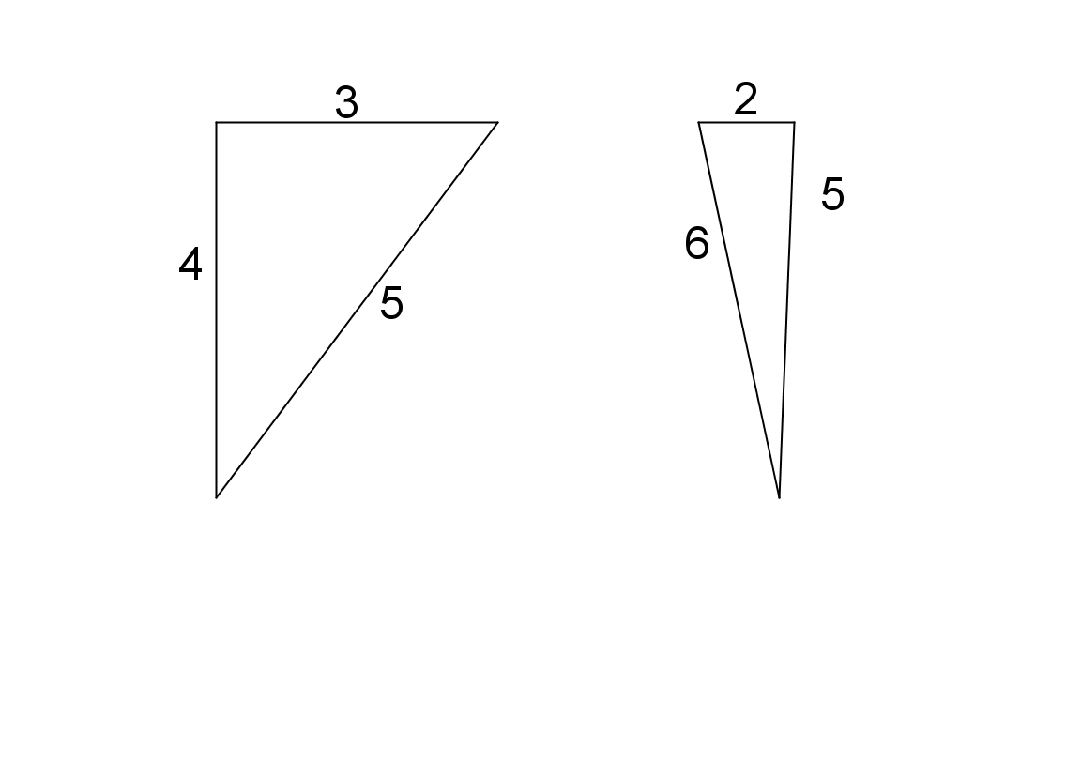
- Are the following right angled triangles. Justify your answer.

[4 marks]
a. b.

No
$2^{2}+5^{2}=29≠36=6^{2}$

Yes
$$\sqrt{3^{2}+4^{2}}=5$$

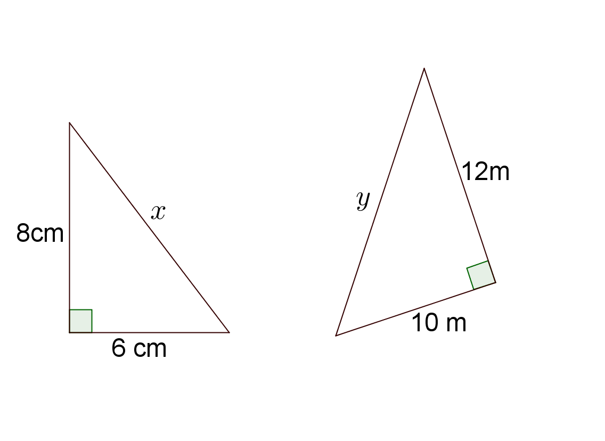
- Find the length of the hypotenuse in the following triangles. Give your answer correct to two decimal places.

[4 marks]
a. b.

$$y=\sqrt{{10}^{2}+{12}^{2}}=15.62m$$

$$x=\sqrt{8^{2}+6^{2}}=10cm$$

- Find the value of the pronumeral in these triangles. Give your answer correct to two decimal places.
[5 marks]
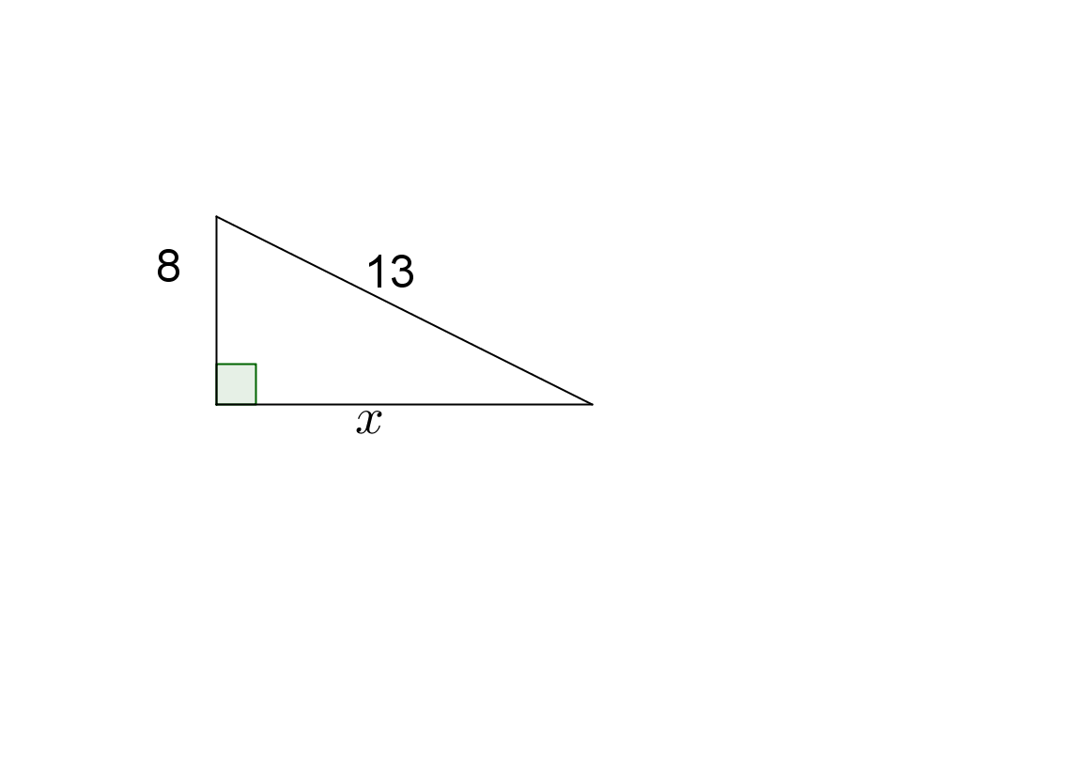
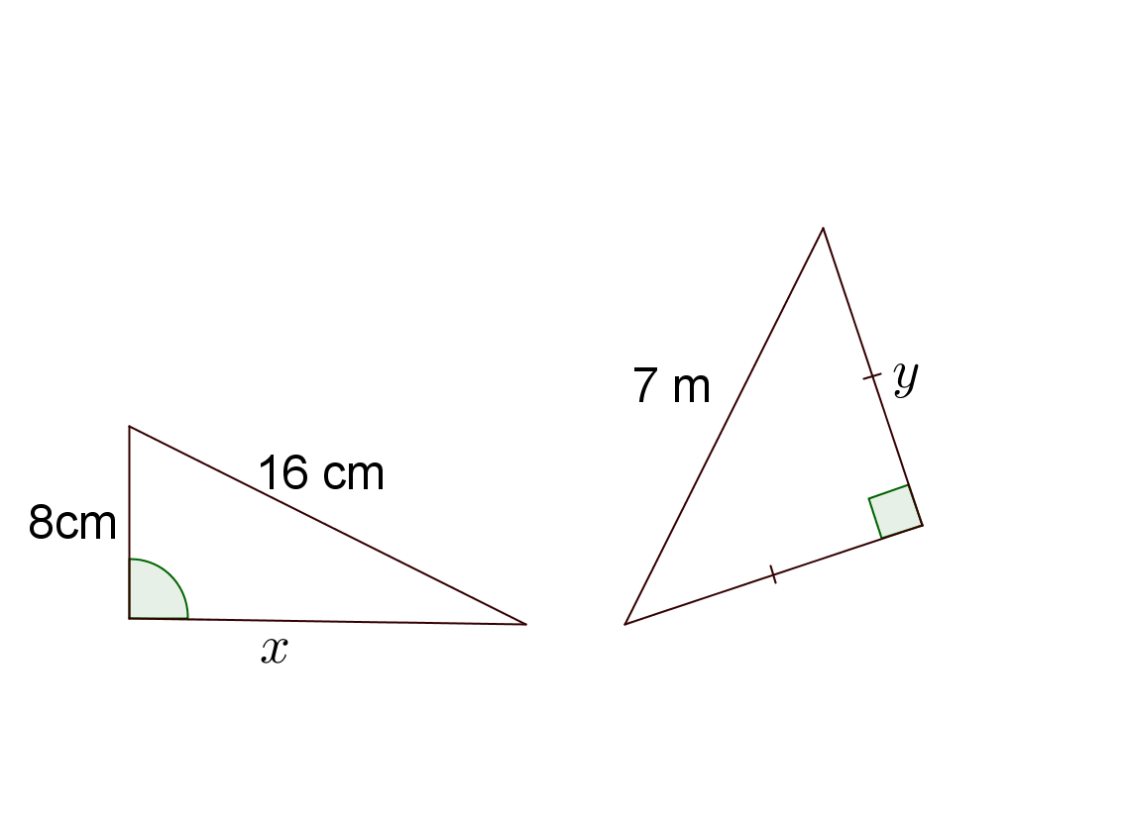

$$y^{2}+y^{2}=49$$
$${2y}^{2}=49 \\ y=\sqrt{\frac{49}{2}} \\ =4.95m$$

$$x=\sqrt{{13}^{2}-8^{2}}=10.2$$

- A 4 m tall ladder reaches 3.7 m up a wall. Find the horizontal distance between the base of the wall and the ladder. Give your answer correct to two decimal places.
[3 marks]

$$x=\sqrt{4^{2}-{3.7}^{2}}=1.52m$$

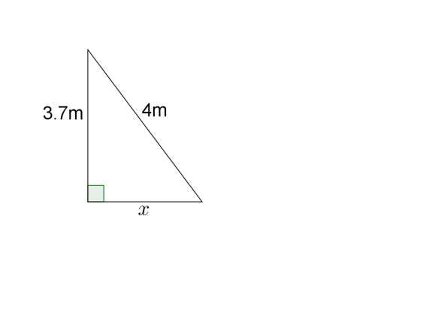

- Two polesTwo poles are located 3.2 m apart. A wire links the tops of the two poles. Find the length of the wire if the poles are 3.8 m and 6 m in height. Give your answer correct to one decimal place.
[3 marks]

$$x=\sqrt{{3.2}^{2}+{\left(6-3.8\right)}^{2}}$$
$=3.9m$

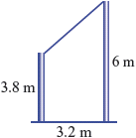

- A rectangular gate measures 1.4 m by 2.5 m with a 2.79m diagonal. Is the gate square? Justify your answer.
If not, should the diagonal be longer or shorter?
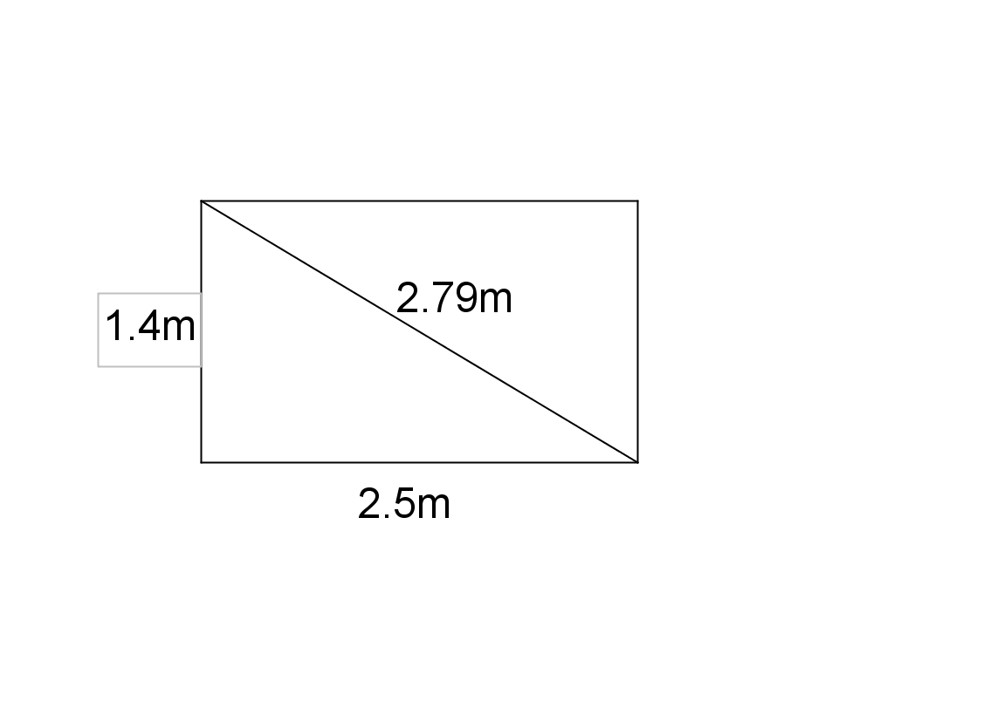
[3 marks]

$$\sqrt{{1.4}^{2}+{2.5}^{2}}$$
$=2.87m$
No not a right angle½ should be longer½

- Find the length of the line AB in the following questions. Give your answers correct to two decimal places.
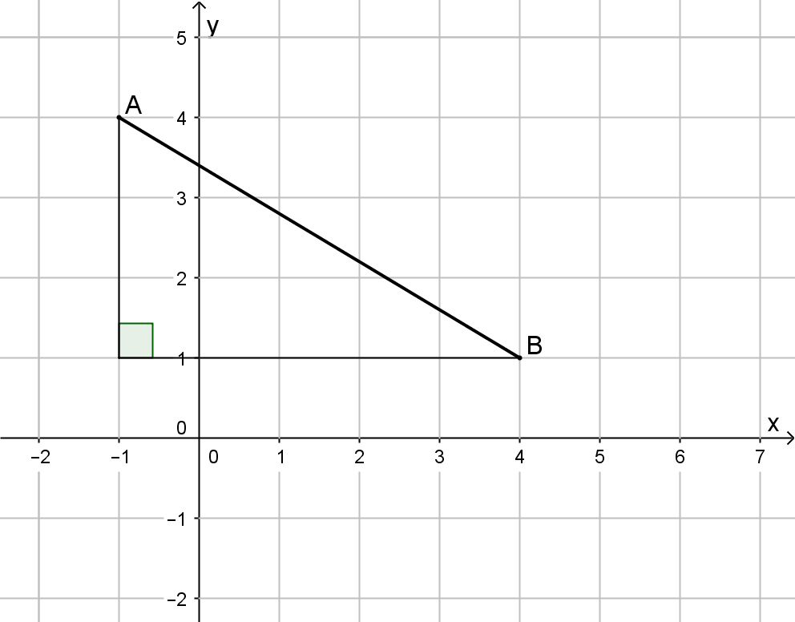
[5 marks]

$$AB=\sqrt{3^{2}+5^{2}}=5.83$$

  - $A\left(-2,3\right)$ and $B(10,-2)$

$$AB=\sqrt{{(10--2)}^{2}+{(-2-3)}^{2}}=13$$

- Consider the following rectangular prism.
[4 marks]
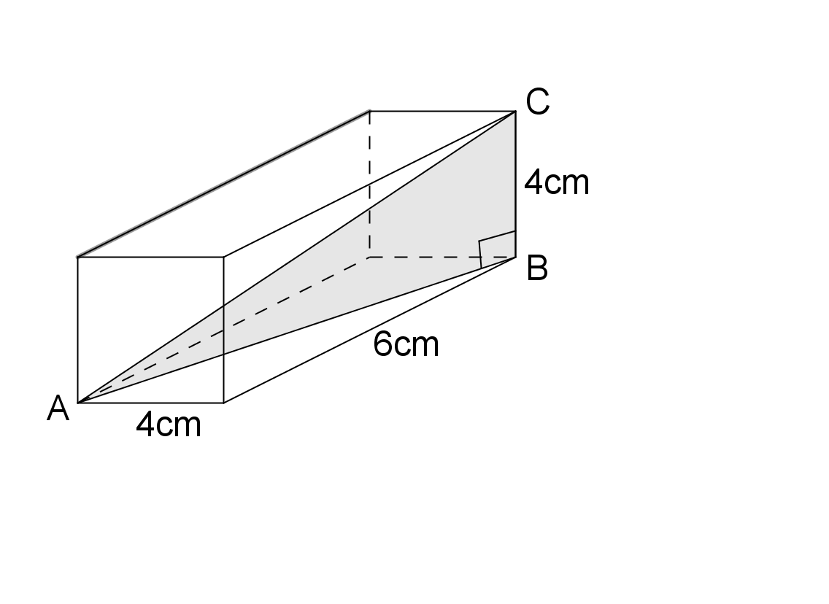

  - Find the length AB as an exact value.

$$AB=\sqrt{4^{2}+6^{2}}=\sqrt{52}cm or 2\sqrt{13}cm$$

  - Hence, find the length AC. Round your answer to two decimal places.

$$A3=\sqrt{52+4^{2}}=8.25cm$$

